**Assignment No. 1:**

**NAMES:** **MUHAMMAD ANNS & SHARIQ**

**Roll NO: FA21-BSE-126 & FA21-BSE-111**

**Section: BSE-C**

**Course:** **PROGRAMMING FUNDAMENTAL**

SUBMITED TO : **MAAM MAMONA**

**Problem Statement**

**Recall the concepts of if statements you learned during your lectures and write a program which takes the positive integer n and x from the user and evaluate the value of y using the following series. The computation should use all terms in the series up through the term involving x n**

**y = x - x3/3! + x5/5! - x7/7! + x9/9! .. xn/n!**

**FlowChart**

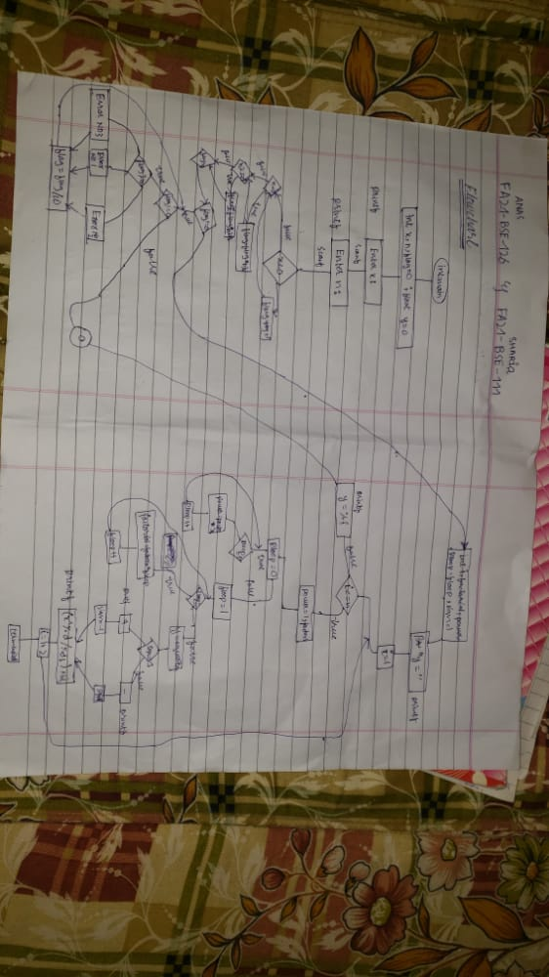

**Program Code**

#include <stdio.h>

int main() {

long long int x, n, flag = 0;

double y = 0;

printf("\t\t\t\tEnter x: ");

scanf("%ld", &x);

printf("\n\t\t _______________________________________\n\n ");

printf("\t\t\t\tEnter n: ");

scanf("%ld", &n);

printf("\n\t\t ________________________________________\n\n ");

if (x < 0){

flag = flag + 1;

}

if (n < 0){

flag = (flag * 10) + 2;

}

if (n%2 == 0){

flag = (flag * 10) + 3;

}

if (flag != 0){

while(flag != 0){

switch(flag%10)

{

case 1:

printf("\t\t Error: x must be a positive integer.\n");

break;

case 2:

printf("\t\t Error: n must be a positive integer.\n");

break;

case 3:

printf("\t\t Error: n must be an odd number.\n");

}

flag = flag/10;

}

}

else {

long long int i, factorial, power, pLoop, fLoop, sign = 1;

printf("\n\t\ty =");

for (i = 1; i <= n; i = i + 2){

power = 1, factorial = 1;

for (pLoop = 0; pLoop < i; pLoop++){

power = power * x;

}

for (fLoop = 1; fLoop <= i; fLoop++){

factorial = factorial * fLoop;

}

y = y + (sign * (power/(double)factorial));

if (sign == 1){

printf(" + ");

sign = -1;

} else {

printf(" - ");

sign = 1;

}

printf("((x^%ld)/%ld!)", i, i);

}

printf("\n\n\t\t\t ________________________________________\n\n ");

printf(" \n\t\t\t\ty= %lf \n\n", y);

}

return 0;

}

**OUTPUT**

